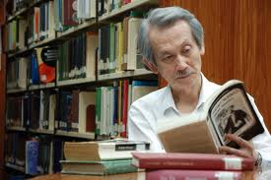
Wang, Wenxing (Wang, Wen-hsing) 王文興 (1939–)
Wang Wenxing is one of the most important fiction writers in the Chinese language in modern times. His experimentation with the Chinese language—pictography and syntax, narrative form, narrating perspectives—together with his exploration of existential themes establishes him as a paramount figure in Taiwan’s literary modernism and Chinese-language literature worldwide.
Born in Fuzhou, Fujian Province, China, Wang and his family moved to Taiwan in 1946 and settled in a small city in southern Taiwan, Donggang. Two years later the family moved to Taipei. Wang received his BA from the Foreign Languages and Literatures Department in National Taiwan University. In 1958 Wang published his first short story “Shou ye” (The lingering night) and a few more stories in the following two years. In 1960 Wang and several of his classmates, including Bai Xianyong, Chen Ruoxi, Ouyan Zi—all of whom later became important writers in Taiwan—founded the journal Xiandai wenxue (Modern literature), which nurtured Taiwan’s modernist movement in the 1960s. After receiving his BA in 1961, Wang served in the military, as was required by law. In 1963 he went to the University of Iowa and received an MFA in creative writing. Two years later, Wang returned to Taiwan and began his career as a writer, literary and film critic, and scholar teaching English and American literature in his alma mater, National Taiwan University. He retired from teaching at the rank of full professor in 2005.
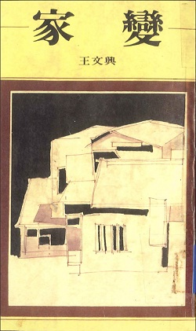
Wang began writing his first novel, Jia bian (Family catastrophe), in 1966. The novel took him seven years to complete. Family Catastrophe was first published and serialized in Chungwai Literary Monthly in September 1972 and was completed in February 1973. The book form was published by Hongfan Bookstore in the following year. Immediately after its publication, Family Catastrophe stirred up a controversy in Taiwan because of the novel’s unconventional challenge of traditional Chinese notions of patriarchy and family structure. Drawing materials from his personal life, Family Catastrophe depicts the evolving relationship between the son and his parents, particularly the father. As the son grew older, his childhood admiration for his father and love for his family turned into disgust and his treatment of the aging and senile father became increasingly abusive and violent. One day the father quietly left the house in his pajamas. As the son searched for the father, he usurped the father’s place in the family. The seemingly lack of morality of the novel disturbed many of its readers who also felt disoriented at the novel’s innovative form and linguistic experimentation. This novel stands as an iconic modernist work in the Chinese language.
Wang began to write his second novel Beihai de ren (Backed against the sea) in 1974. The first volume of this novel was published in 1981 by Hongfan Bookstore.
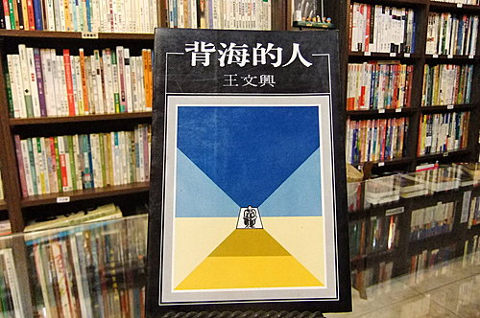
The 1981 edition of Backed Against the Sea, vol. 1. The cover is a painting by Wang himself.
The second volume was not completed until 1997. It was first published and serialized in Lianhe wenxue (Unitas) from January to June, 1999. The book form, published by Hongfan Bookstore, came out in September of the same year. Backed Against the Sea continues Wang’s modernist style and narrative techniques and innovation with the Chinese language. The novel is a long stream of consciousness and interior monologue of a handicapped and diseased retired soldier whose downtrodden predicaments, along with petty characters of similar situations, give expression to Wang’s existential views on life and religious faith as well as his skepticism of modernity. Backed Against the Sea is an absurdist comedy of the human condition.
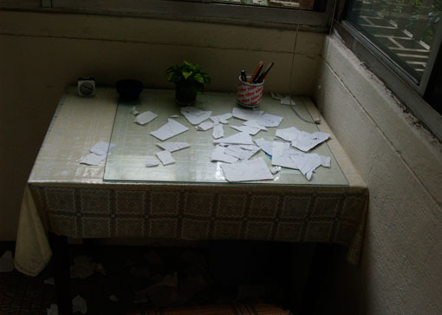
“The writer’s prison cell,” as Wang calls the small space in which he writes.

Although Wang published only two novels, both are hailed as among the most important and innovative literary works in the Chinese language. He crafts his words in the most meticulous way possible. A true wordsmith, it is said that Wang only writes thirty-five words a day. In 2000, Wang donated the manuscripts of Family Catastrophe and Backed Against the Sea, along with notes and letters, to National Taiwan University Library.
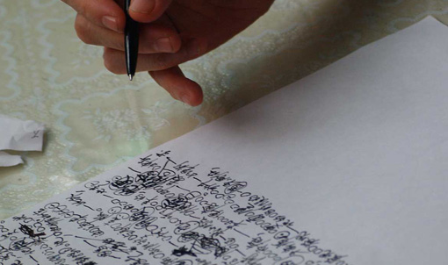
Wang only writes on scraps of paper as he crafts his words.

Chronology of All Works:
Short Story Collections
Longtian lou (Dragon inn) (1967).
A collection of short stories on the civil war between the Nationalist Party and the Communist Party (1946-1949) and the post-1949 period in Taiwan

Wanju shouqiang (The toy revolver) (1970).
A collection of novellas and sketches

Shiwupian xiaoshuo (Fifteen short stories) (1981).

Novels

Jia bian (Family catastrophe) (1974).

Beihai de ren (Backed against the sea), vol. 1 (1981) and vol. 2 (1999).
A two-volume novel on the life of a former soldier who chooses to live in an impoverished fishing village in order to have minimum contact with the society.
Essay Collections
Shu he ying (Books and films) (1988).
A collection of critical essays on literature and film.

Xiaoshuo yu mo (Beyond fiction) (2002).
Miscellaneous writings.

Xingyulou suixiang (Random thoughts from the star-rain tower) (2003).
Reflections on religious faith, theology, aesthetics, and philosophy.
Plays
M he W (M and W) (1988).
A play in the style of the theater of the absurd, exploring the question of trust
between people.

Works Available in English:
Family Catastrophe, translated by Susan Wan Dolling. Honolulu: University of Hawaii
Press, 1995.

Backed against the Sea, translated by Edward Gunn. Ithaca, N.Y.: East Asia
Program, Cornell University, 1993.

References and Further Reading:
Endless War: Fiction and Essays by Wang Wen-hsing. Eds. by Shu-ning Sciban and Fred
Edwards. Ithaca, NY: Cornell East Asian Program, Cornell University, 2011.
This volume consists of a wide range of Wang’s writings, apart from his novels.

Chang, Yvonne Sung-Sheng. “Language, Narrative and Stream of Consciousness: The

two novels of Wang Wen-hsing.” Modern Chinese Literature 1, 1 (1984): 43-56.

A helpful guide to Wang’s narrative techniques and experimentation with language.

-----. “Wang Wenxing’s Backed Against the Sea, Parts I and II: The Meaning of
Modernism in Taiwan’s Contemporary Literature.” In David Wang and Carlos Rojas
eds., Writing Taiwan: A New Literary History. Durham, NC: Duke UP, 2006, 156-79.
This article examines Wang’s novel Back Against the Sea in the context of Taiwan’s literary
modernism.

Lupke, Christopher. “Wang Wenxing and the ‘Loss’ of China.” Boundary 2. Special
Issue, ed. Rey Chow. 25, 2 (Fall 1998): 97-128.
This article discusses and analyzes Family Catastrophe against the historical backdrop
of the Nationalist’s anti-mainland rhetoric during the Cold War..

